Evaluation: Random Forest
Accuracy: 0.972
Precision: 0.9720737661497049
Recall: 0.972
F1 Score: 0.9719697344287697
Jaccard Index: 0.9457341547369328
Matthews CorrCoef: 0.9650330046931505
Cohen’s Kappa: 0.965
Specificity: 0.993
AUC: 0.9986125
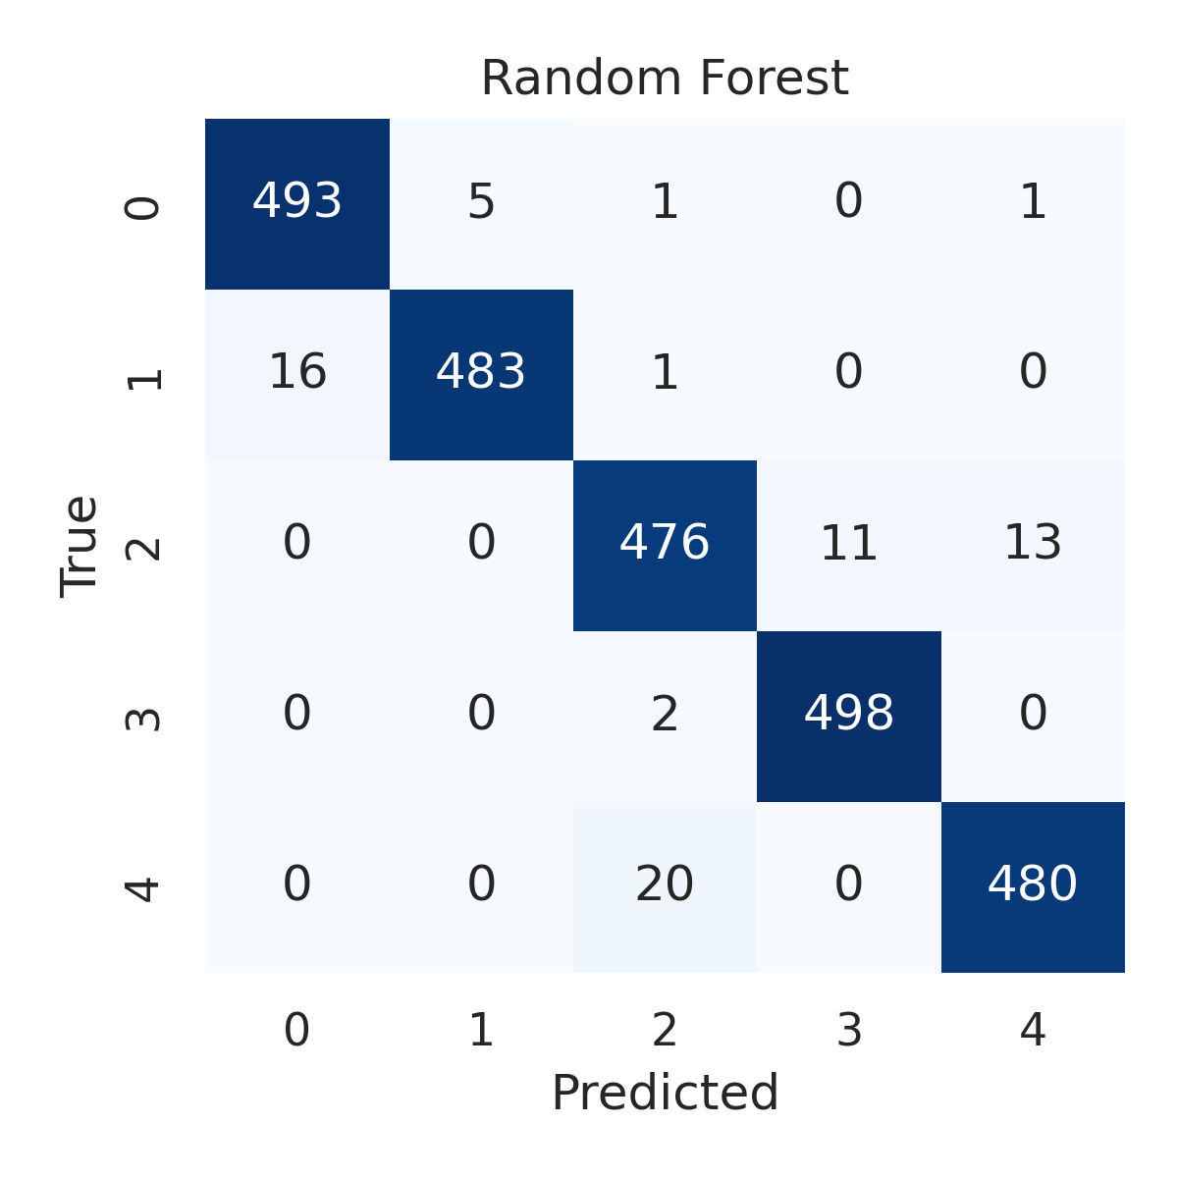

Combined ROC Curves
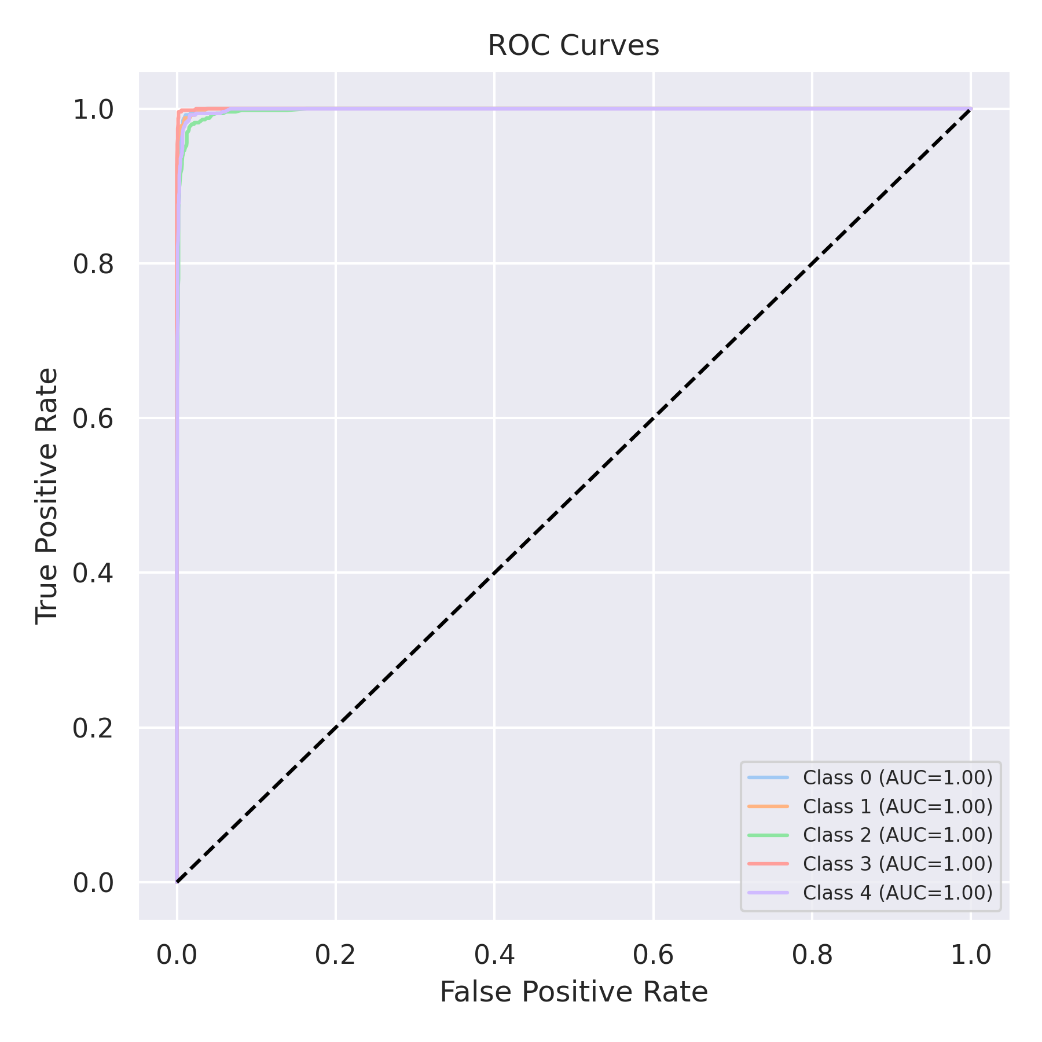

Evaluation: K-Nearest Neighbors
Accuracy: 0.9016
Precision: 0.9031674659174882
Recall: 0.9016
F1 Score: 0.9009369391754326
Jaccard Index: 0.821092830042077
Matthews CorrCoef: 0.8776933004532048
Cohen’s Kappa: 0.877
Specificity: 0.9754000000000002
AUC: 0.9863374999999999
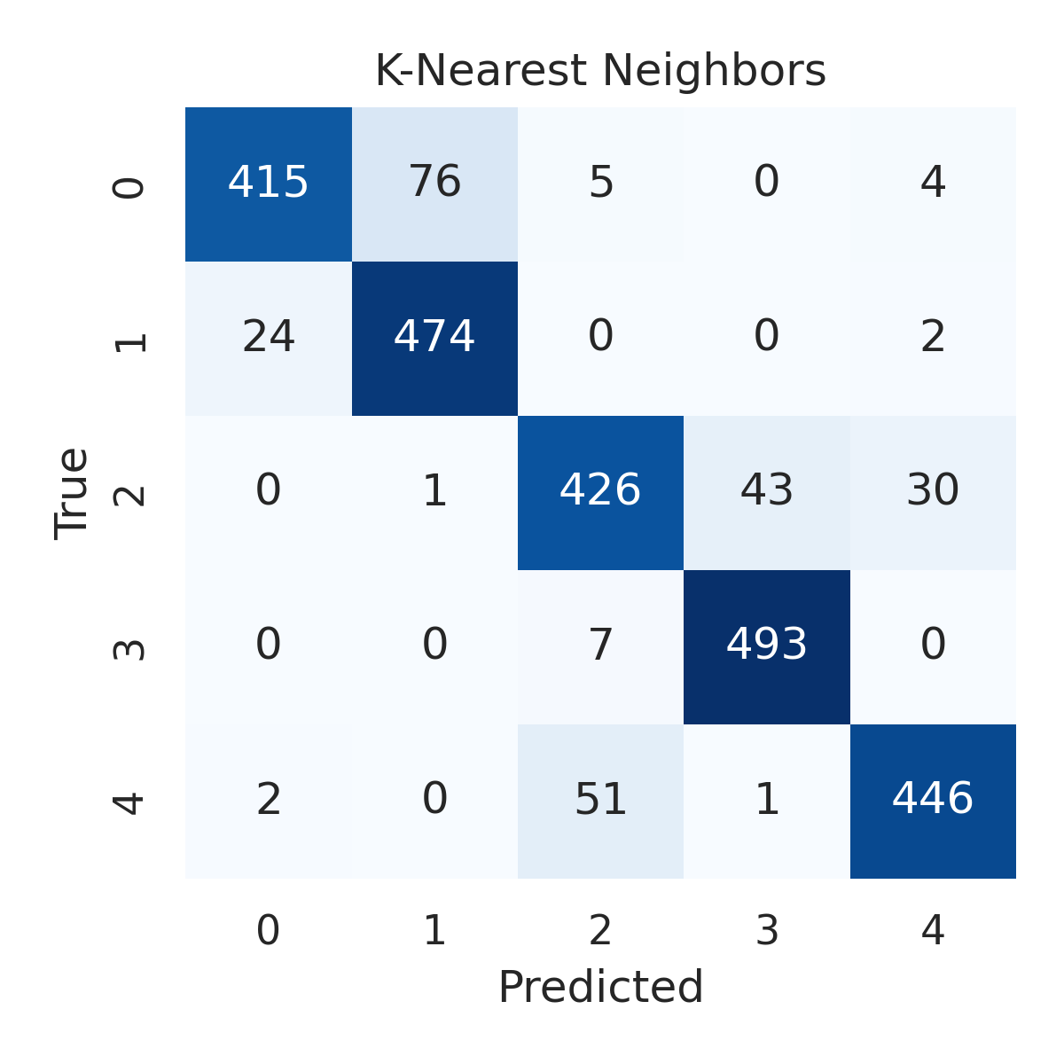

Combined ROC Curves
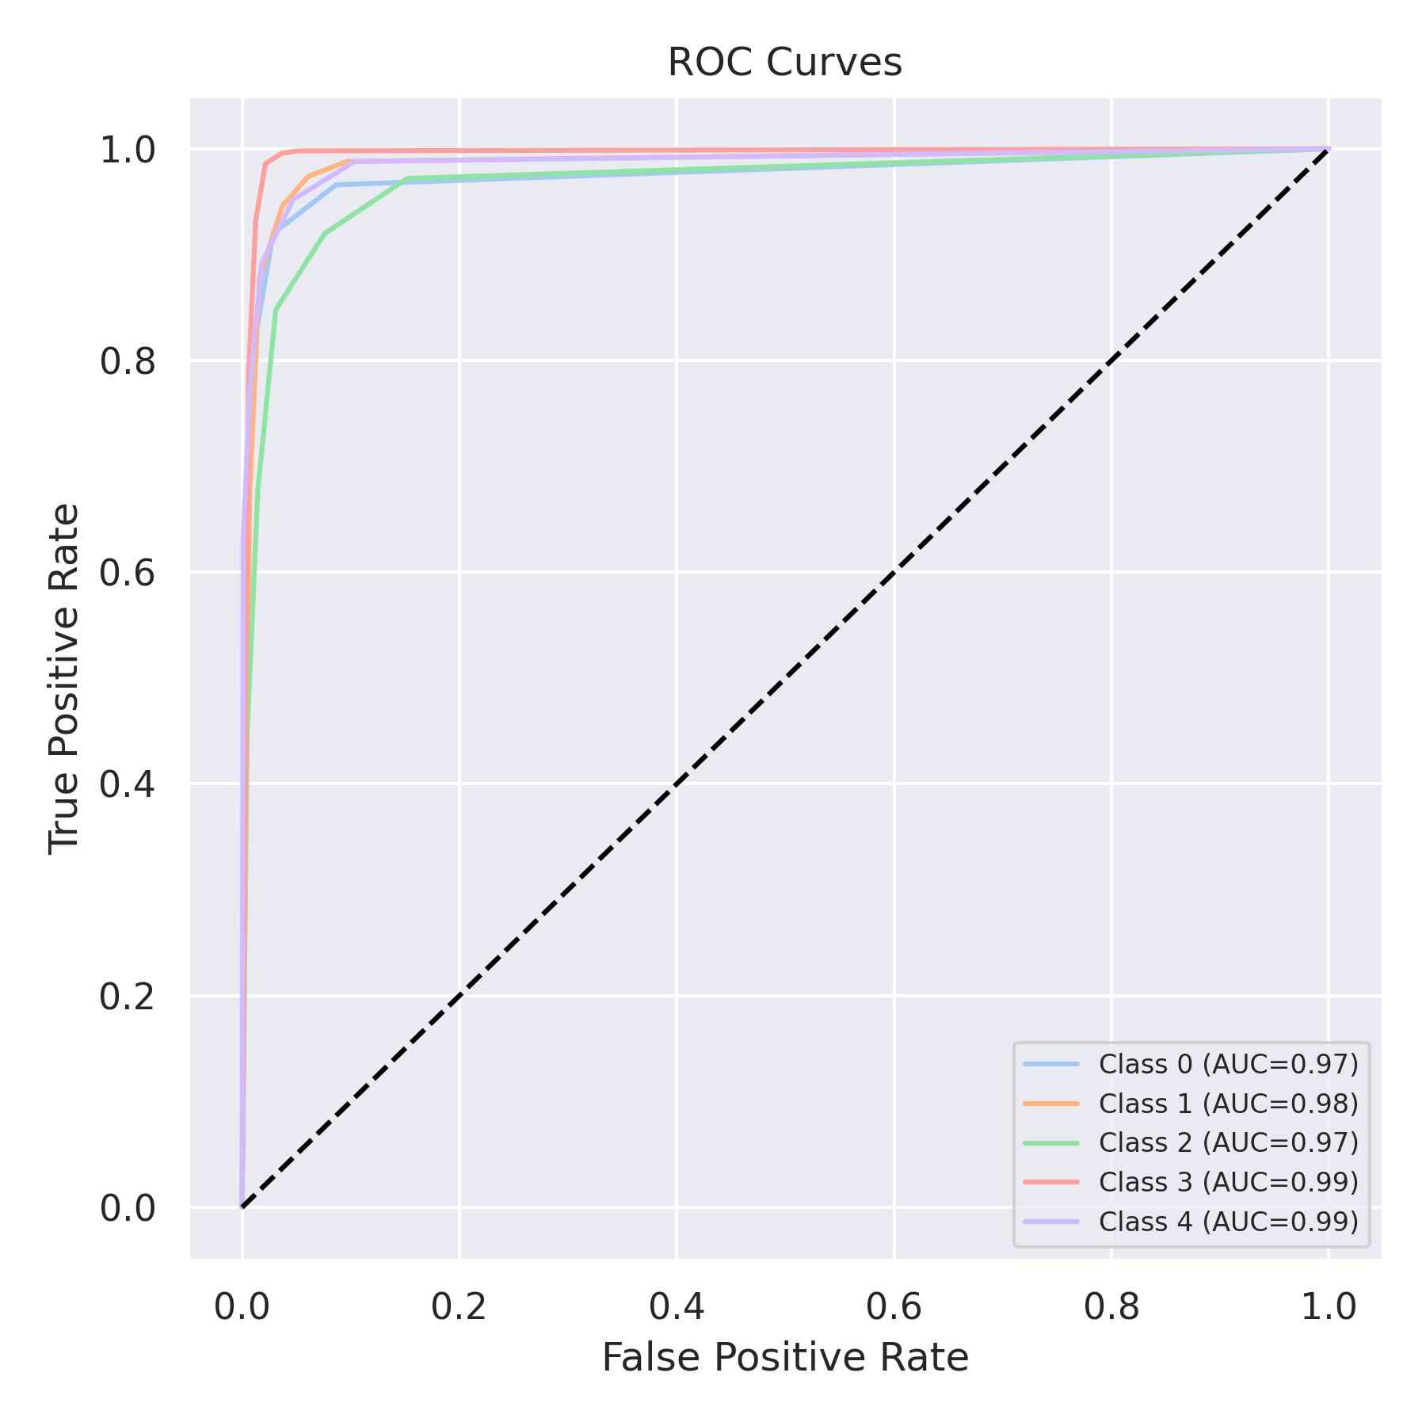

Evaluation: Decision Tree
Accuracy: 0.9632
Precision: 0.9632794024116033
Recall: 0.9632
F1 Score: 0.9631498211007951
Jaccard Index: 0.9293284311062333
Matthews CorrCoef: 0.954044268681124
Cohen’s Kappa: 0.954
Specificity: 0.9907999999999999
AUC: 0.9712500000000001
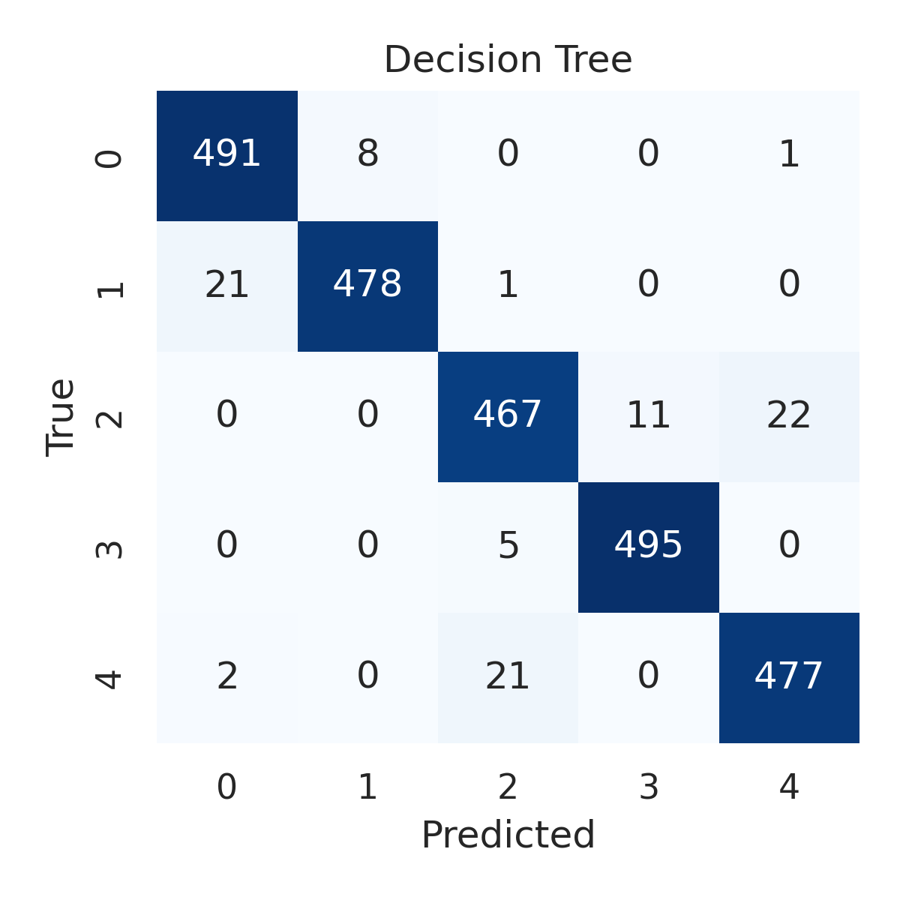

Combined ROC Curves
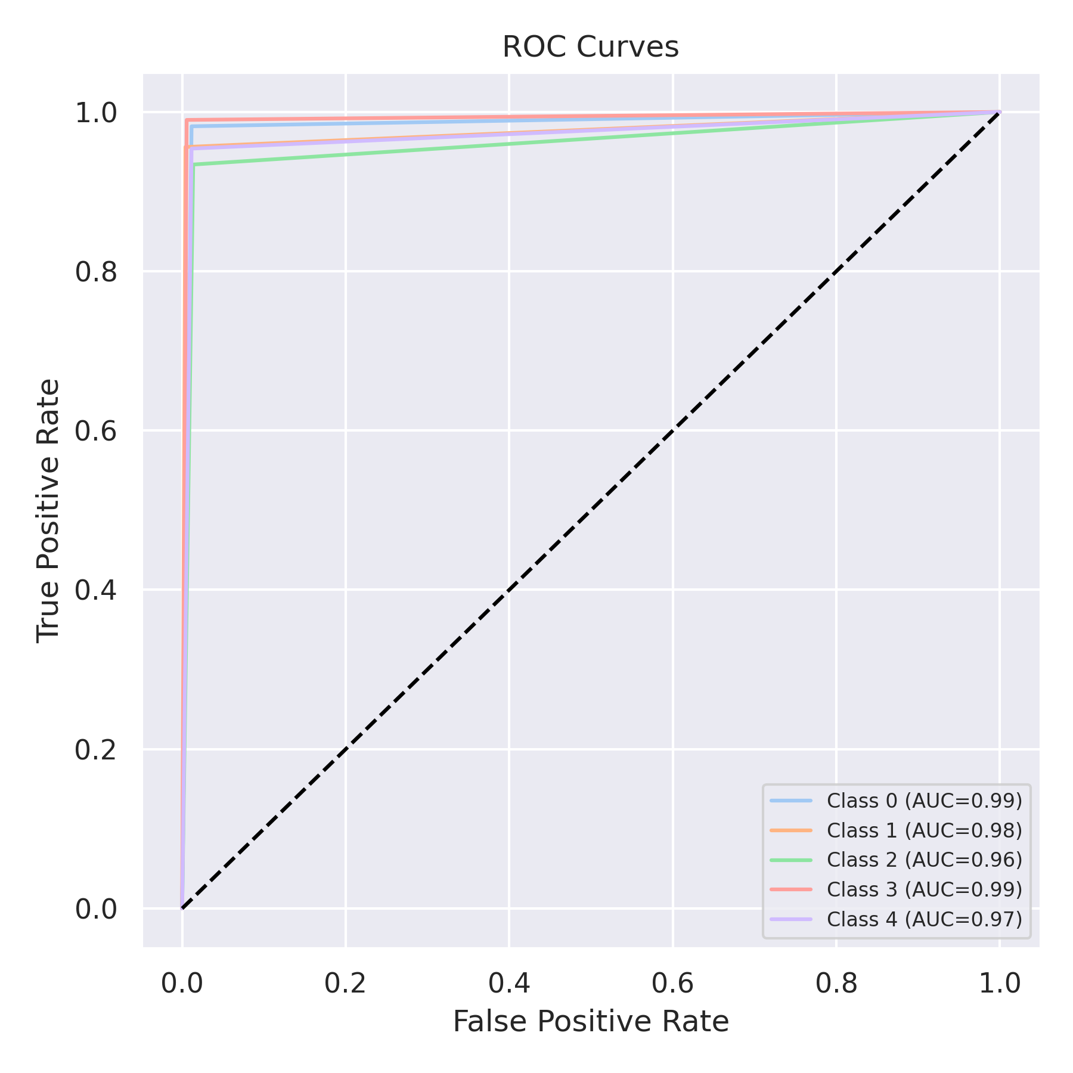

Evaluation: Extra Trees
Accuracy: 0.9732
Precision: 0.973251465418167
Recall: 0.9732
F1 Score: 0.9731736888156148
Jaccard Index: 0.9479293522567709
Matthews CorrCoef: 0.9665257099258305
Cohen’s Kappa: 0.9665
Specificity: 0.9933000000000002
AUC: 0.9986085
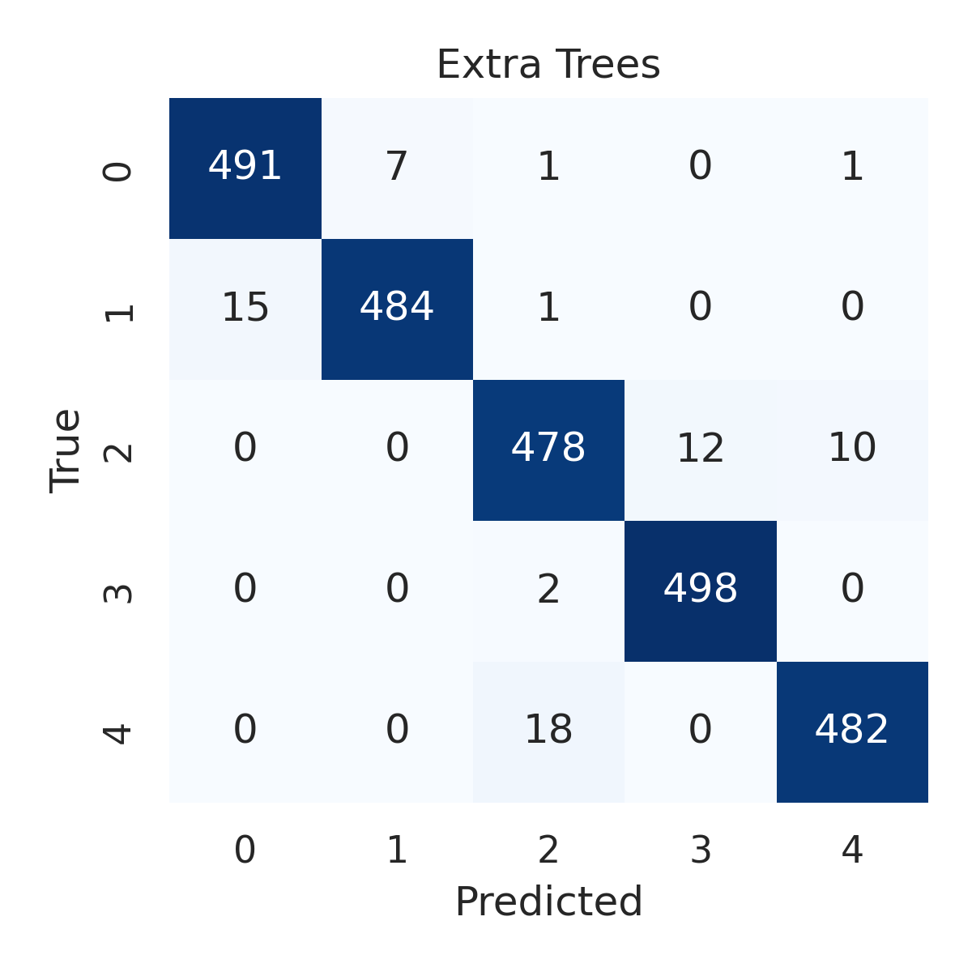

Combined ROC Curves
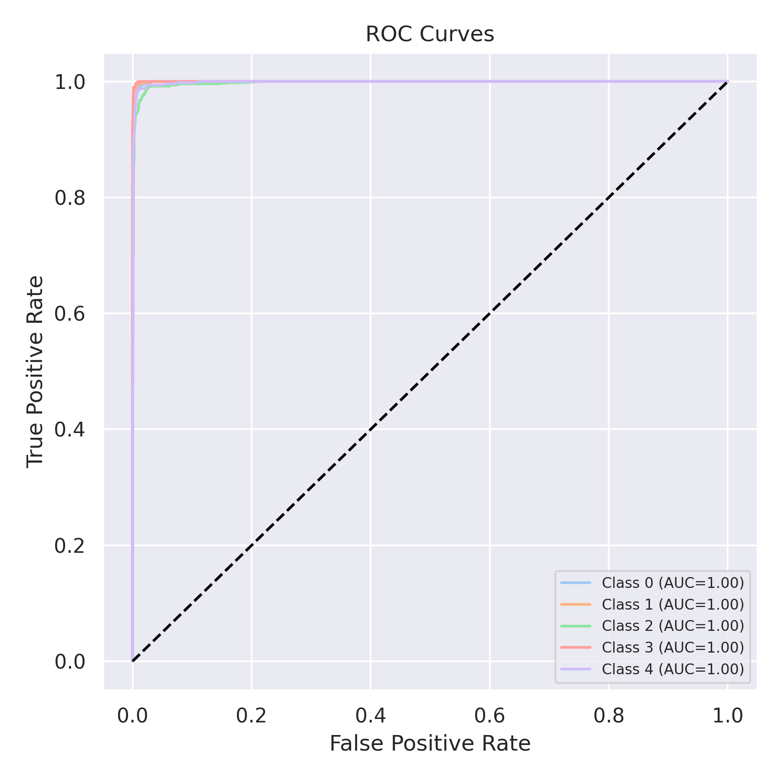

Evaluation: Bagging Classifier
Accuracy: 0.9732
Precision: 0.9734108754535289
Recall: 0.9732
F1 Score: 0.9732172599924821
Jaccard Index: 0.9480478864984568
Matthews CorrCoef: 0.9665436887621205
Cohen’s Kappa: 0.9665
Specificity: 0.9933
AUC: 0.9980355
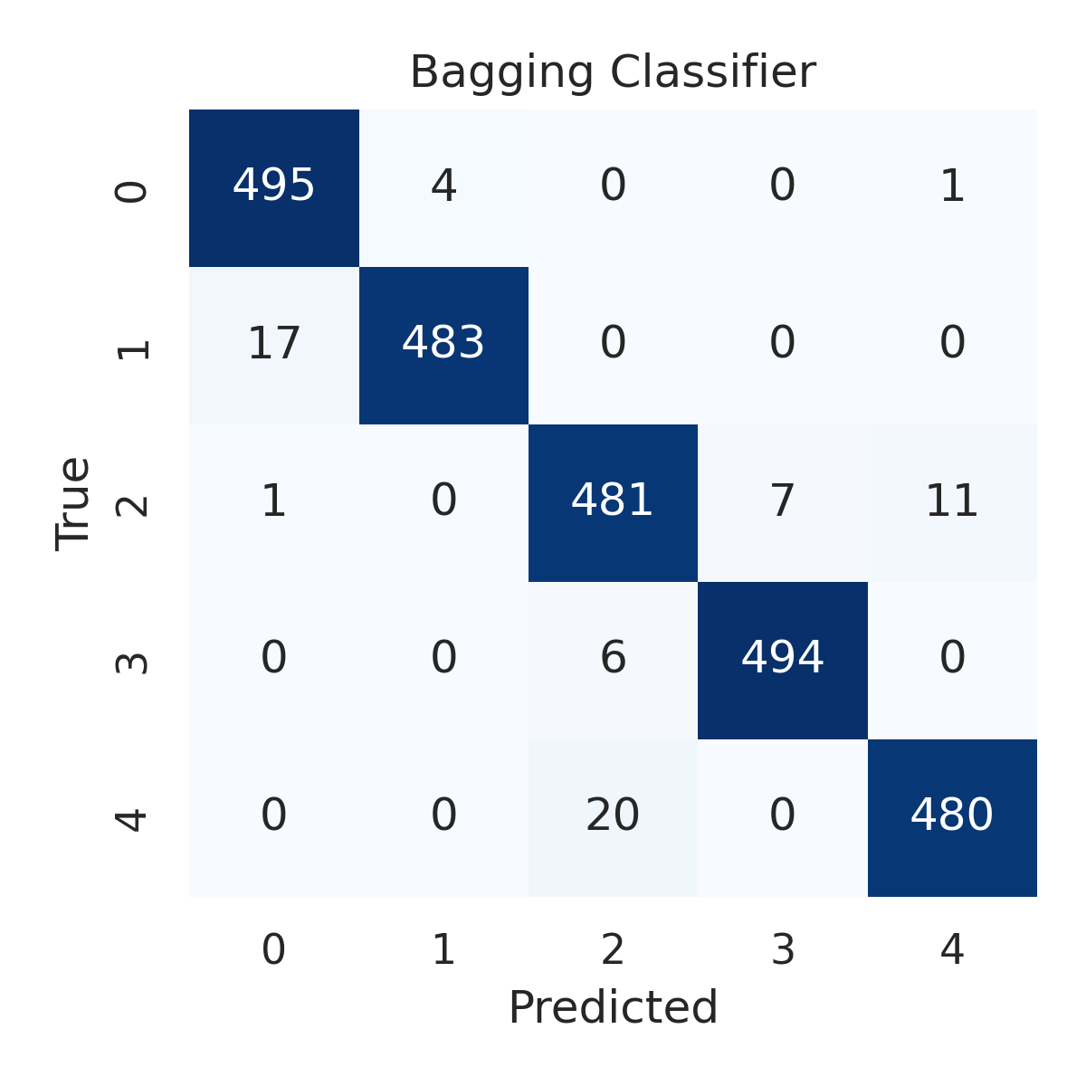

Combined ROC Curves
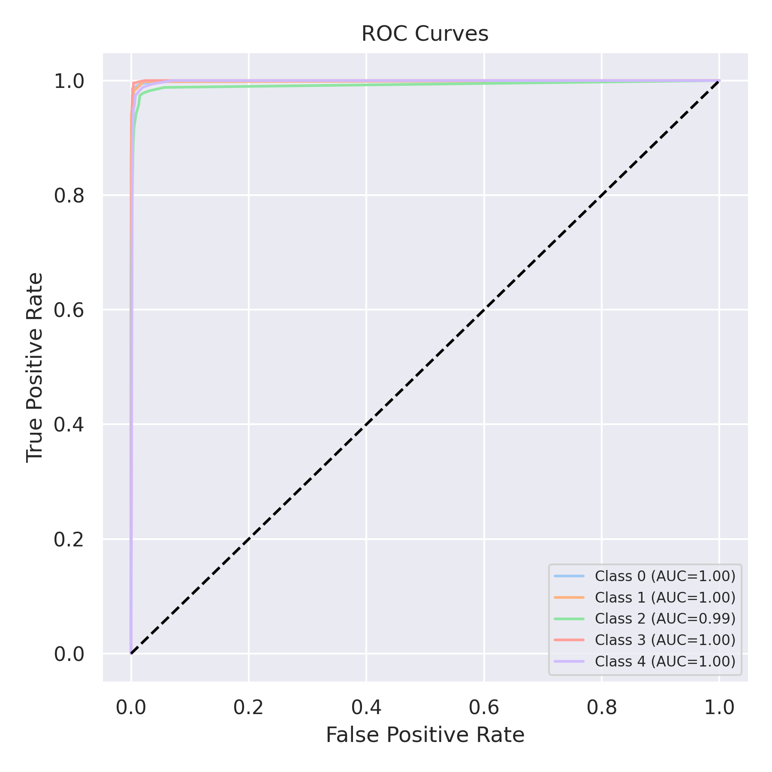

Evaluation: XGBoost
Accuracy: 0.9864
Precision: 0.986408485701518
Recall: 0.9864
F1 Score: 0.9863935127177614
Jaccard Index: 0.9732955032801524
Matthews CorrCoef: 0.9830053082429968
Cohen’s Kappa: 0.983
Specificity: 0.9966000000000002
AUC: 0.9991279999999999
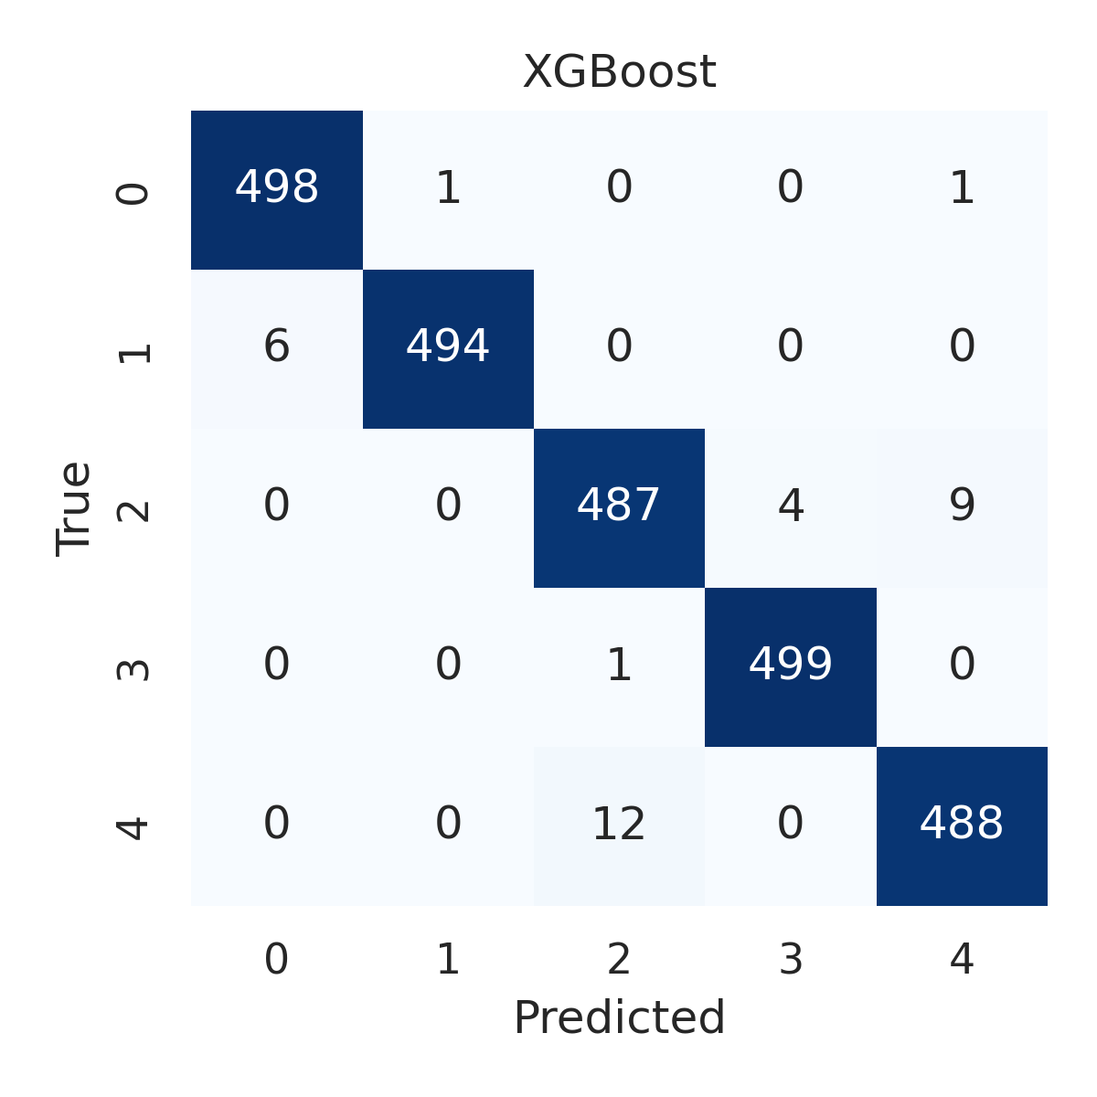

Combined ROC Curves
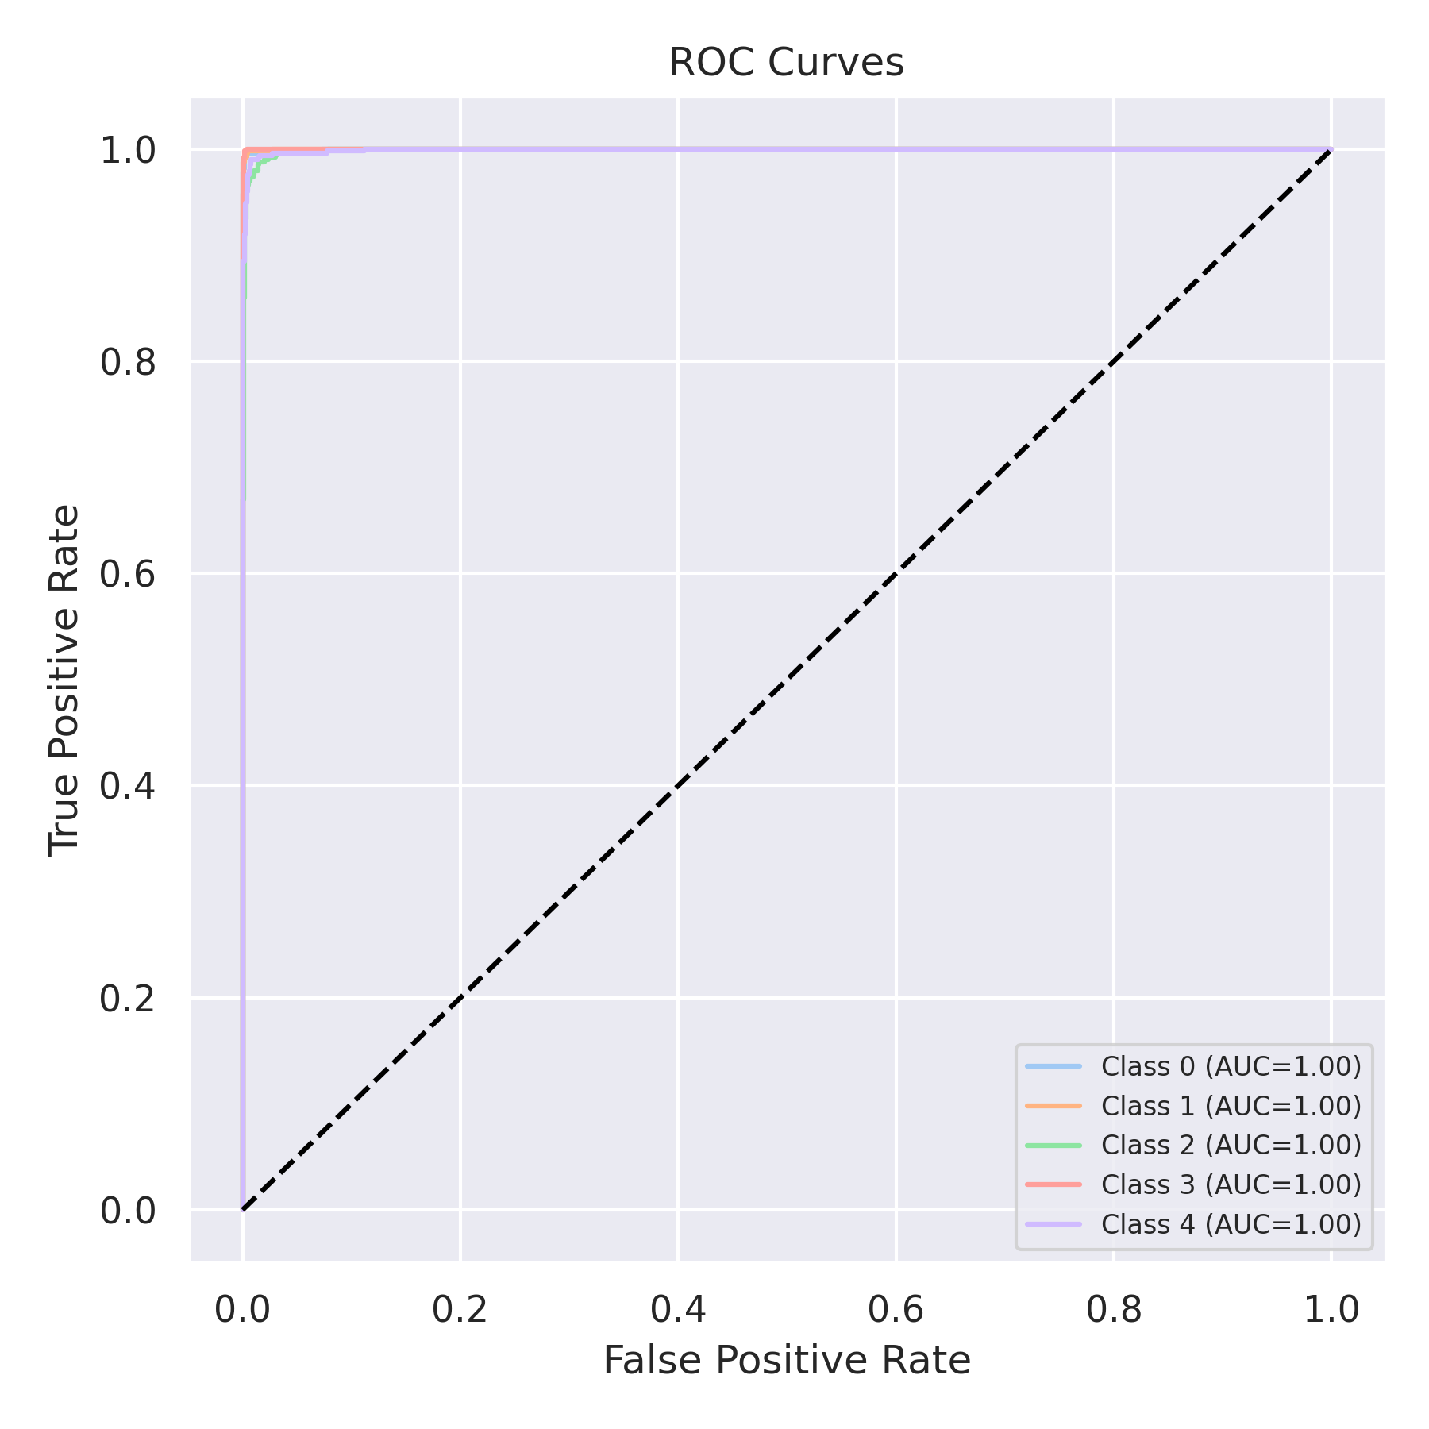

Evaluation: LightGBM
Accuracy: 0.9832
Precision: 0.9831925161291474
Recall: 0.9832
F1 Score: 0.983191527880666
Jaccard Index: 0.96708832090568
Matthews CorrCoef: 0.9790023496084586
Cohen’s Kappa: 0.979
Specificity: 0.9958000000000002
AUC: 0.9992420000000001
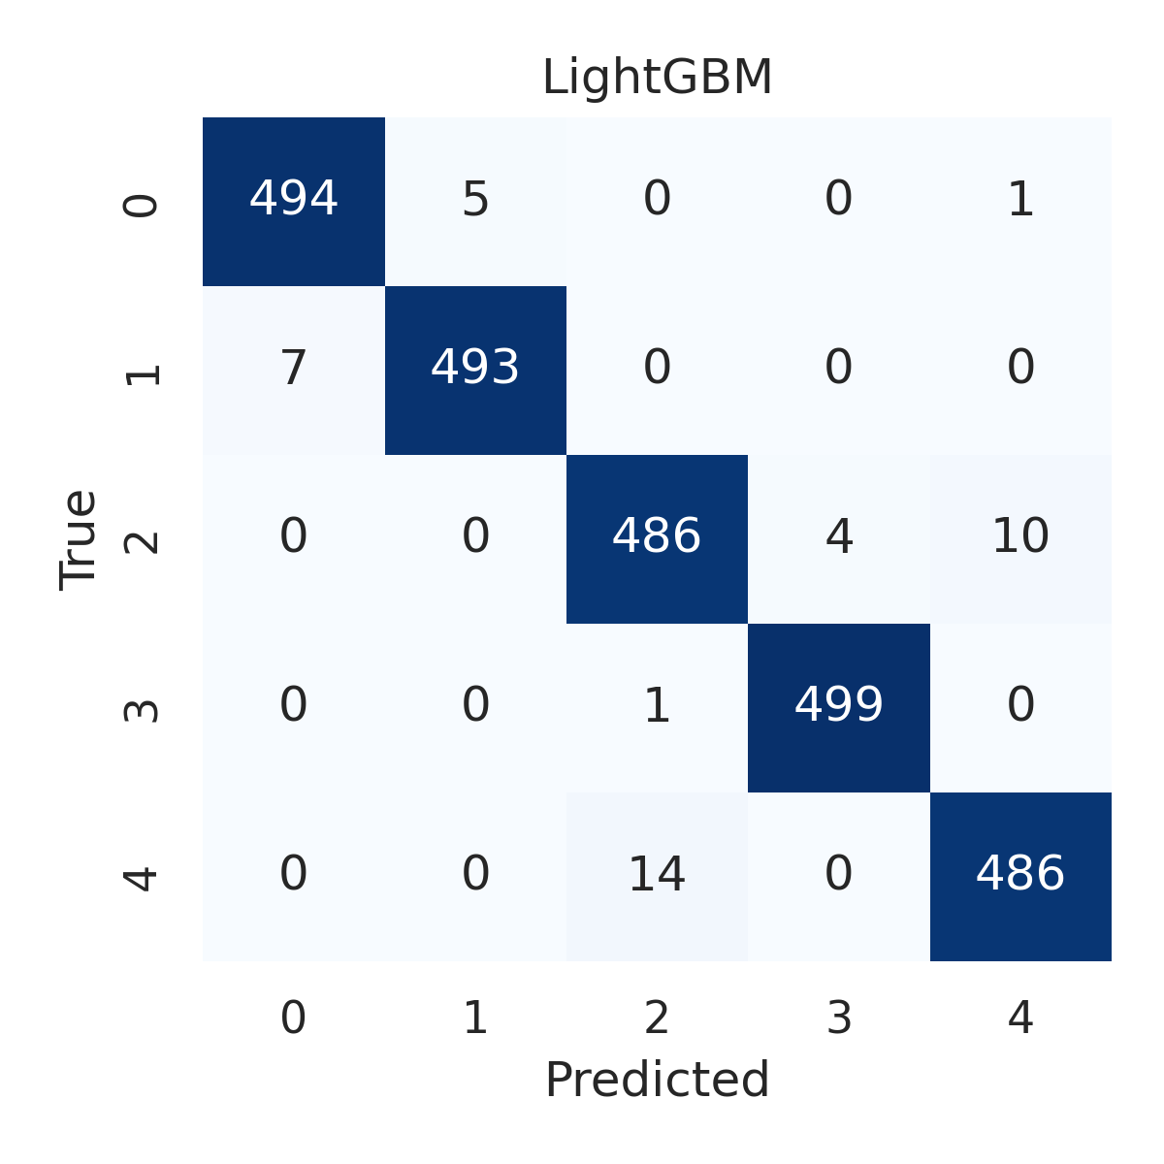

Combined ROC Curves
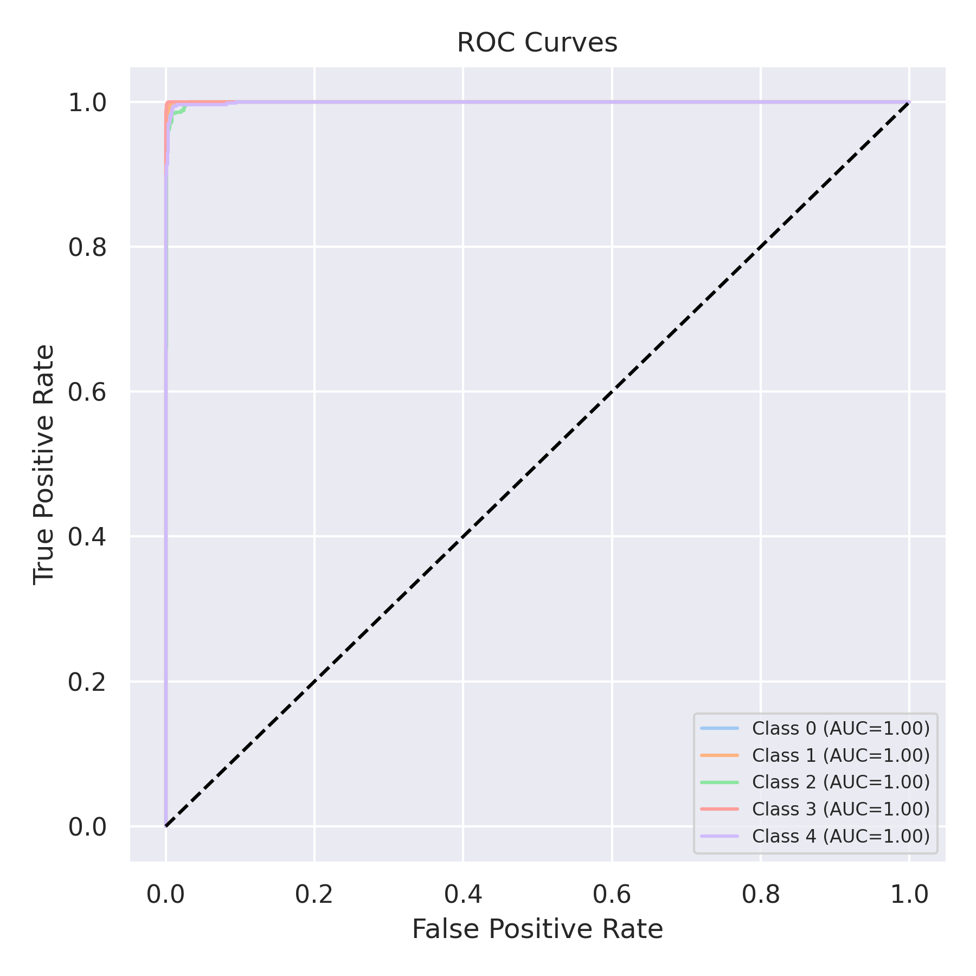

Evaluation: CatBoost
Accuracy: 0.2
Precision: 0.04
Recall: 0.2
F1 Score: 0.06666666666666667
Jaccard Index: 0.04
Matthews CorrCoef: 0.0
Cohen’s Kappa: 0.0
Specificity: 0.8
AUC: 0.998972
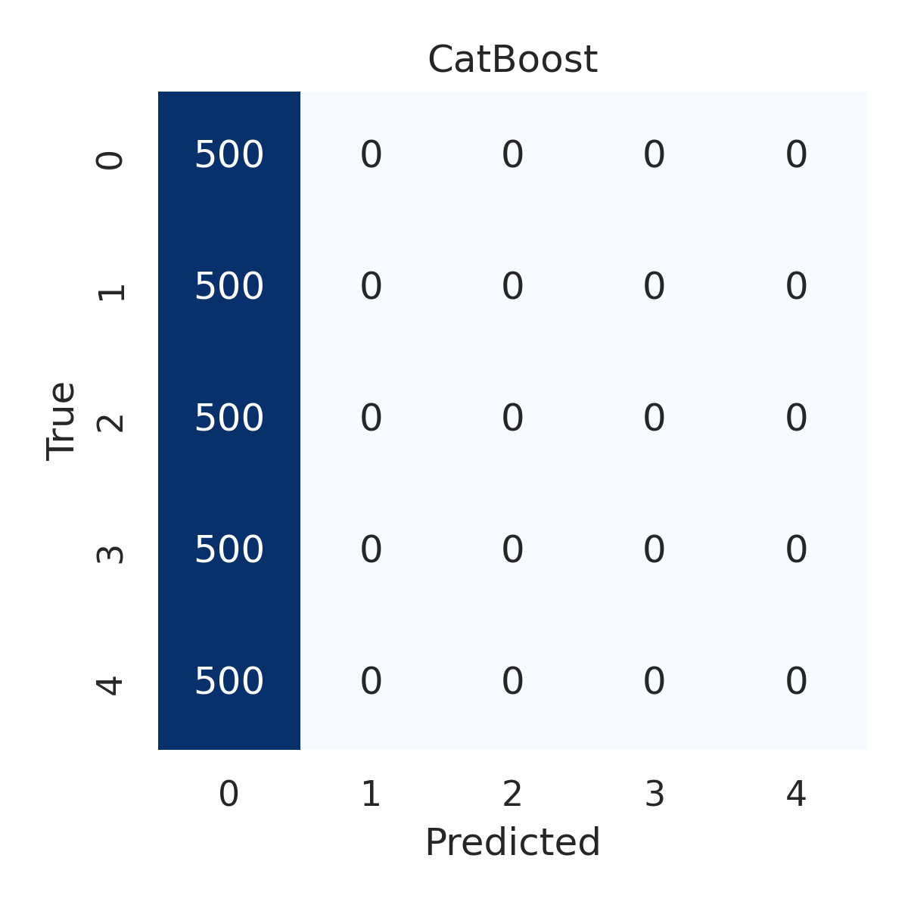

Combined ROC Curves
